Homework 5

Q1.Import “FAA-1.xls” into R

library("rJava")

library("xlsxjars")

library("xlsx")

faa1dataset<-read.xlsx("FAA1.xls",1,header=TRUE,stringsAsFactors = default.stringsAsFactors())

Q2. Do data cleaning using the attached information.

# summary describes the data, the result shows that there are missing valus in speed_air variable.

#replacing all missing values with mean of that variable

summary(faa1dataset)

aircraft duration no_pasg speed_ground speed_air height

airbus:400 Min. : 14.76 Min. :29.00 Min. : 27.74 Min. : 90.00 Min. :-3.546

boeing:400 1st Qu.:119.49 1st Qu.:55.00 1st Qu.: 65.87 1st Qu.: 96.16 1st Qu.:23.338

Median :153.95 Median :60.00 Median : 79.64 Median :100.99 Median :30.147

Mean :154.01 Mean :60.13 Mean : 79.54 Mean :103.83 Mean :30.122

3rd Qu.:188.91 3rd Qu.:65.00 3rd Qu.: 92.33 3rd Qu.:109.48 3rd Qu.:36.981

Max. :305.62 Max. :87.00 Max. :141.22 Max. :141.72 Max. :59.946

NA's :600

pitch distance

Min. :2.284 Min. : 34.08

1st Qu.:3.658 1st Qu.: 900.95

Median :4.020 Median :1267.44

Mean :4.018 Mean :1544.52

3rd Qu.:4.388 3rd Qu.:1960.44

Max. :5.927 Max. :6533.05

There are 600 missing values in speed_air

Omitting na values

faa1dataset<-na.omit(faa1dataset)

#Data Preprocessing

resldataset<-faa1dataset[(faa1dataset$duration)>40,]

resldataset<-resldataset[resldataset$speed_ground>30,]

resldataset<-resldataset[resldataset$speed_ground<140,]

resldataset<-resldataset[resldataset$distance<6000,]

resldataset<-resldataset[resldataset$speed_air>30,]

resldataset<-resldataset[resldataset$speed_air<140,]

finaldataset<-resldataset[,2:dim(resldataset)[2]];

Q3) Do data visualization using R

summary(faa1dataset)

aircraft duration no_pasg speed_ground speed_air height

airbus:400 Min. : 14.76 Min. :29.00 Min. : 27.74 Min. : 90.00 Min. :-3.546

boeing:400 1st Qu.:119.49 1st Qu.:55.00 1st Qu.: 65.87 1st Qu.: 96.16 1st Qu.:23.338

Median :153.95 Median :60.00 Median : 79.64 Median :100.99 Median :30.147

Mean :154.01 Mean :60.13 Mean : 79.54 Mean :103.83 Mean :30.122

3rd Qu.:188.91 3rd Qu.:65.00 3rd Qu.: 92.33 3rd Qu.:109.48 3rd Qu.:36.981

Max. :305.62 Max. :87.00 Max. :141.22 Max. :141.72 Max. :59.946

NA's :600

pitch distance

Min. :2.284 Min. : 34.08

1st Qu.:3.658 1st Qu.: 900.95

Median :4.020 Median :1267.44

Mean :4.018 Mean :1544.52

3rd Qu.:4.388 3rd Qu.:1960.44

Max. :5.927 Max. :6533.05

cor(finaldataset)

duration no_pasg speed_ground speed_air height pitch distance

duration 1.00000000 -0.0403495644 -0.051917974 0.0233018467 0.010810083 -0.04289099 -0.05317204

no_pasg -0.04034956 1.0000000000 -0.008571678 0.0007538724 0.001719813 -0.00651743 -0.02613177

speed_ground -0.05191797 -0.0085716781 1.000000000 0.2398451039 -0.022110859 -0.05350143 0.86797421

speed_air 0.02330185 0.0007538724 0.239845104 1.0000000000 -0.039769370 -0.02650357 0.40546086

height 0.01081008 0.0017198133 -0.022110859 -0.0397693697 1.000000000 0.02233026 0.13487894

pitch -0.04289099 -0.0065174295 -0.053501426 -0.0265035744 0.022330263 1.00000000 0.06616551

distance -0.05317204 -0.0261317665 0.867974207 0.4054608635 0.134878936 0.06616551 1.00000000

from the above correlation matrix, distance and speed_ground and speed_air has high correlation

lets examine the assumption for a model of the relationship between distance and speed_ground and speed_air

distance is the dependent variable or outcome.

**Q4)** Do model fitting and model diagnostics using R (what variable would you keep in the model?)

Lets fit the linear regression model to predict the distance using speed_ground and speed_air

But speed_ground and speed_air are highly correlated

cor(finaldataset$speed_ground,finaldataset$speed_air,method="pearson")

0.9883475

model1<-lm(finaldataset$distance~finaldataset$speed_ground+finaldataset$speed_air+finaldataset$no_pasg+finaldataset$height,data=finaldataset)

summary(model1)

#Check normally distributed

hist(model1$residuals)

model2<-lm(finaldataset$distance~finaldataset$speed_ground+finaldataset$speed_air,data=finaldataset)

summary(model2)

#Check normally distributed

hist(model2$residuals)

model1 not normal.

Model2 residuals normally distributed

model2<-lm(finaldataset$distance~finaldataset$speed_ground+finaldataset$speed_air, data=finaldataset)

summary(model2)

#Check normally distributed

hist(model2$residuals)

summary(model2)

Call:

lm(formula = finaldataset$distance ~ finaldataset$speed_ground +

finaldataset$speed_air, data = finaldataset)

Residuals:

Min 1Q Median 3Q Max

-986.67 -307.64 -61.05 269.17 1444.69

Coefficients:

Estimate Std. Error t value Pr(>|t|)

(Intercept) -5604.6299 310.3478 -18.06 <2e-16 ***

finaldataset$speed_ground 39.2329 0.7977 49.18 <2e-16 ***

finaldataset$speed_air 38.7124 3.0751 12.59 <2e-16 ***

---

Signif. codes: 0 ‘***’ 0.001 ‘**’ 0.01 ‘*’ 0.05 ‘.’ 0.1 ‘ ’ 1

Residual standard error: 411 on 788 degrees of freedom

Multiple R-squared: 0.7947, Adjusted R-squared: 0.7942

F-statistic: 1525 on 2 and 788 DF, p-value: < 2.2e-16

Residuals are very useful for checking the model assumptions

For fitting new regression model, the following assumptions will be considered

1.independet – check whether residuals are independent

2.Normally distributed

3.Mean 0

4.Constant variance

To test the above assumptions, we use R diagnostic plots

1. Independent test

As the p-value is much less than 0.05, we reject the null hypothesis that *β*= 0. Hence there is a significant relationship between the variables in the linear regression model of the data set faithful

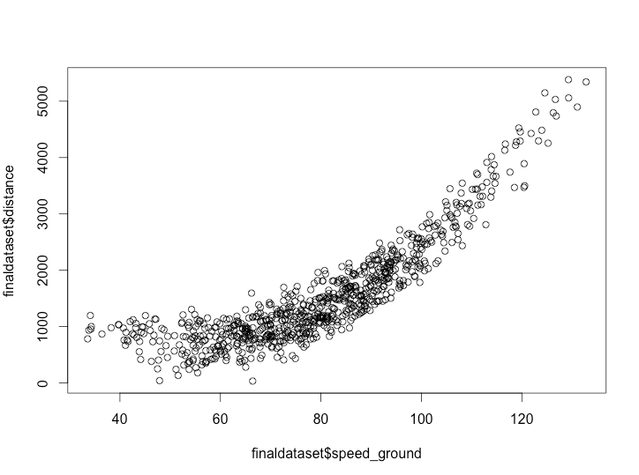

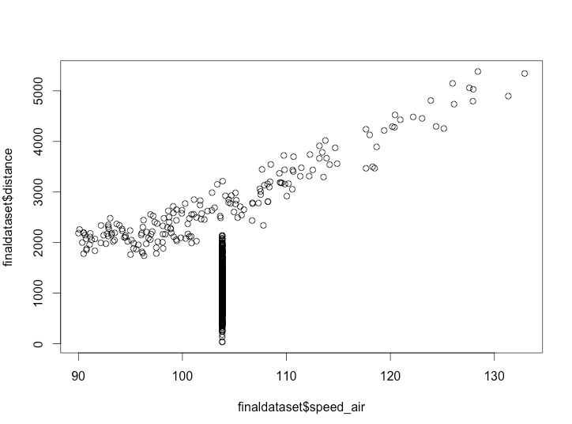

While speed_air value increasing, distance also increasing. Slope is positive

2.Normally distributed

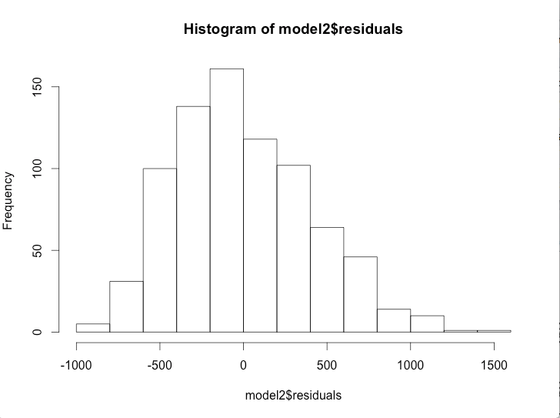

3. Mean =0 and constant variance

t.test(model$residuals,finaldataset$speed_ground)

Welch Two Sample t-test

data: model$residuals and finaldataset$speed_ground

t = -5.8262, df = 793.84, p-value = 8.24e-09

alternative hypothesis: true difference in means is not equal to 0

95 percent confidence interval:

-106.23931 -52.69204

sample estimates:

mean of x mean of y

-4.577228e-14 7.946567e+01

t.test(model$residuals,finaldataset$speed_air)

Welch Two Sample t-test

data: model$residuals and finaldataset$speed_air

t = -7.6152, df = 790.26, p-value = 7.522e-14

alternative hypothesis: true difference in means is not equal to 0

95 percent confidence interval:

-130.49297 -77.00588

sample estimates:

mean of x mean of y

-4.577228e-14 1.037494e+02

4.Constant variance

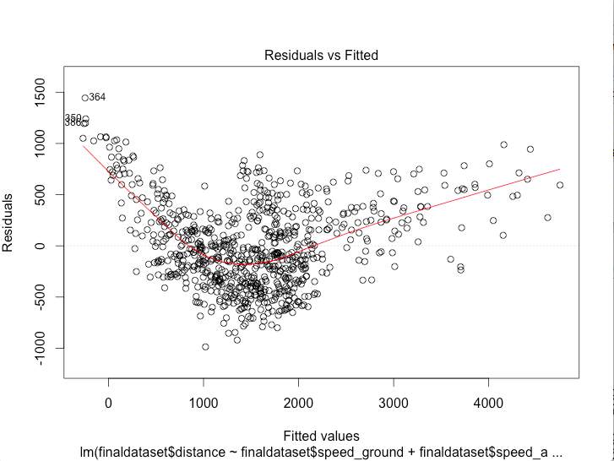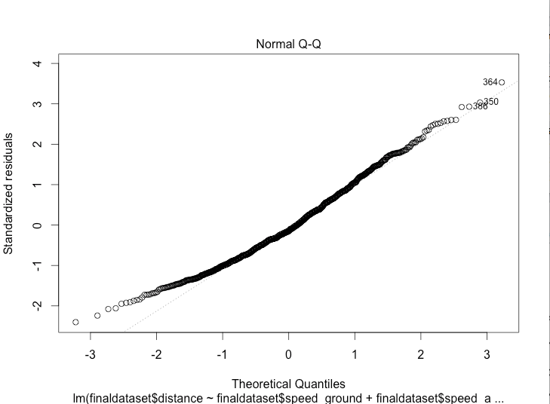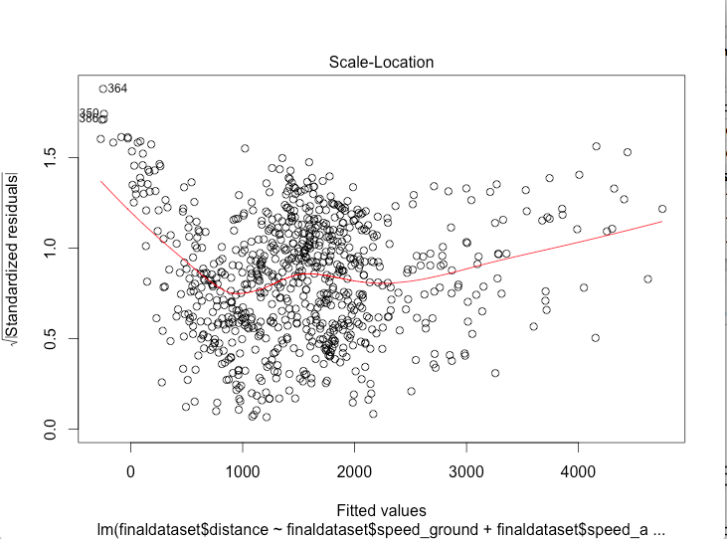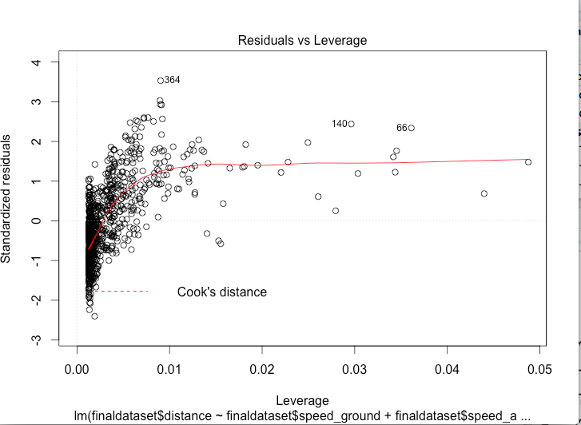

5)

Model for aircraft make boing

boeing<-resldataset[resldataset$aircraft=="boeing",]

boeing<-resldataset[,2:dim(resldataset)[2]];

boeingmodel2<-lm(boeing$distance~boeing$speed_ground+boeing$speed_air)

hist(boeingmodel2$residuals)

qqnorm(boeingmodel2$residuals)

qqline(boeingmodel2$residuals, col = "red")

plot(boeingmodel2)

summary(boeing)

duration no_pasg speed_ground speed_air height pitch distance

Min. : NA Min. : NA Min. : NA Min. : NA Min. : NA Min. : NA Min. : NA

1st Qu.: NA 1st Qu.: NA 1st Qu.: NA 1st Qu.: NA 1st Qu.: NA 1st Qu.: NA 1st Qu.: NA

Median : NA Median : NA Median : NA Median : NA Median : NA Median : NA Median : NA

Mean :NaN Mean :NaN Mean :NaN Mean :NaN Mean :NaN Mean :NaN Mean :NaN

3rd Qu.: NA 3rd Qu.: NA 3rd Qu.: NA 3rd Qu.: NA 3rd Qu.: NA 3rd Qu.: NA 3rd Qu.: NA

Max. : NA Max. : NA Max. : NA Max. : NA Max. : NA Max. : NA Max. : NA

summary(boeingmodel2)

Call:

lm(formula = boeing$distance ~ boeing$speed_ground + boeing$speed_air)

Residuals:

Min 1Q Median 3Q Max

-986.67 -307.64 -61.05 269.17 1444.69

Coefficients:

Estimate Std. Error t value Pr(>|t|)

(Intercept) -5604.6299 310.3478 -18.06 <2e-16 ***

boeing$speed_ground 39.2329 0.7977 49.18 <2e-16 ***

boeing$speed_air 38.7124 3.0751 12.59 <2e-16 ***

---

Signif. codes: 0 ‘***’ 0.001 ‘**’ 0.01 ‘*’ 0.05 ‘.’ 0.1 ‘ ’ 1

Residual standard error: 411 on 788 degrees of freedom

Multiple R-squared: 0.7947, Adjusted R-squared: 0.7942

F-statistic: 1525 on 2 and 788 DF, p-value: < 2.2e-16

For fitting new regression model, the following assumptions will be considered

1.independet – check whether residuals are independent

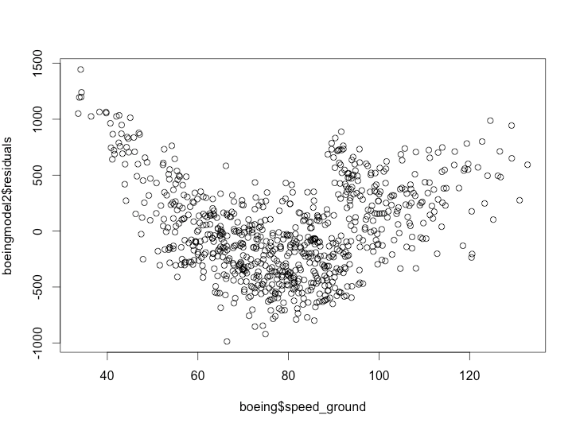

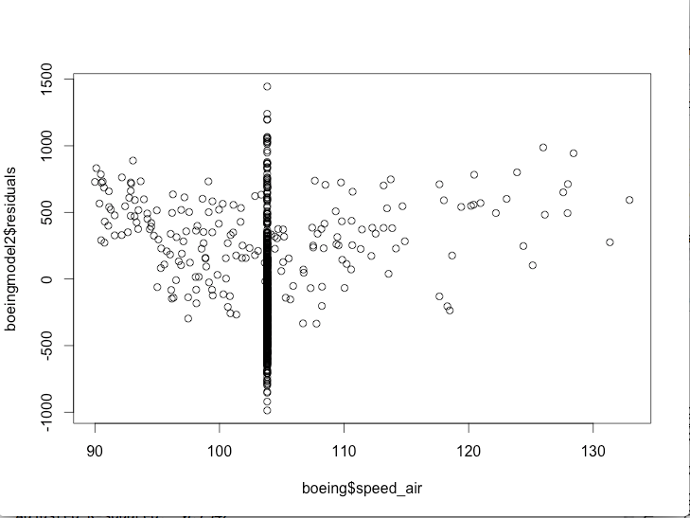

2.Normally distributed

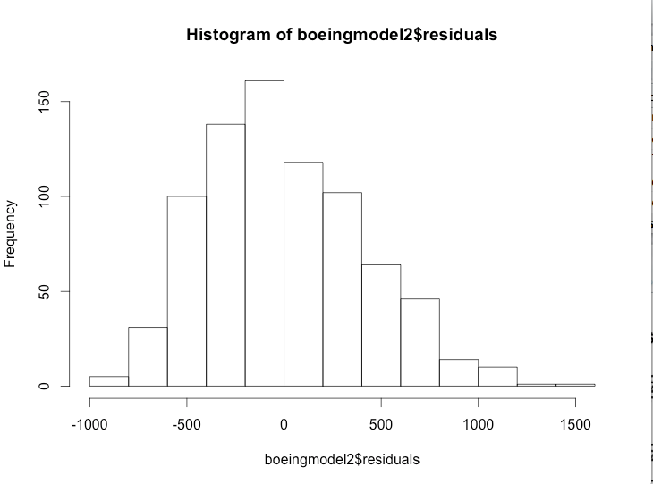

3.Mean 0

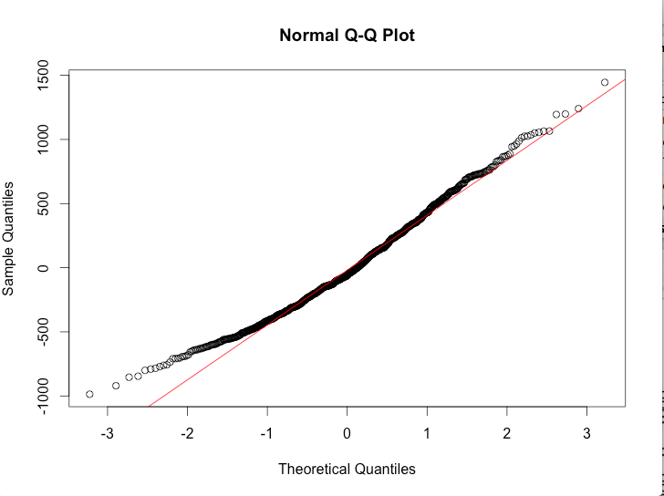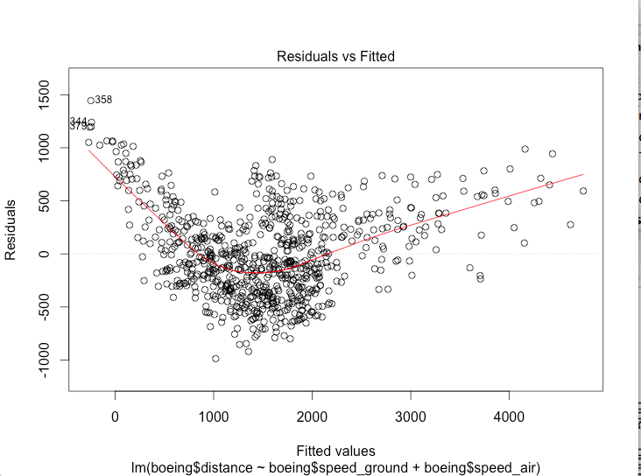

4.Constant variance

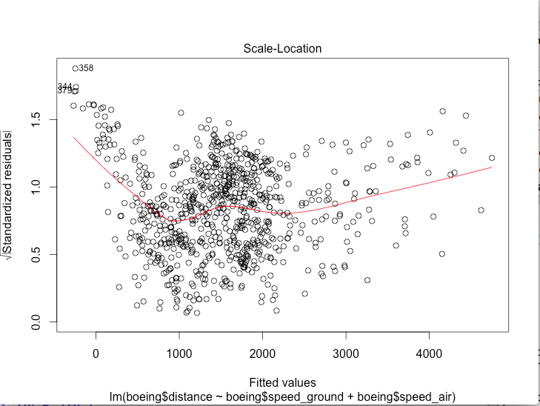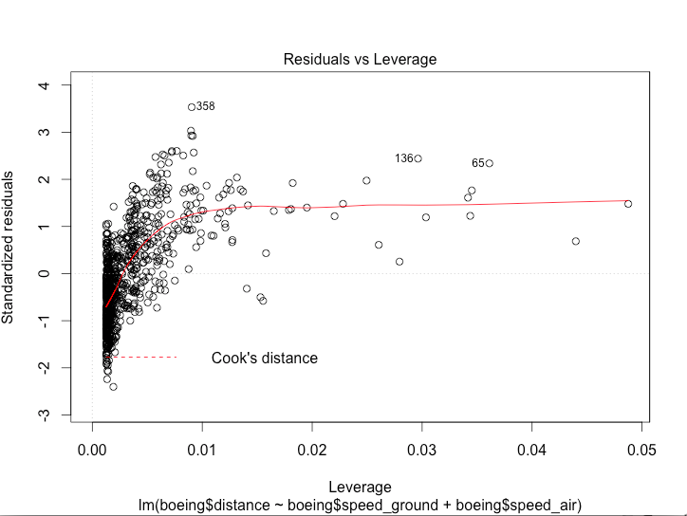

Airbus

airbus<-resldataset[resldataset$aircraft=="airbus",]

airbus<-resldataset[,2:dim(resldataset)[2]];

duration no_pasg speed_ground speed_air height pitch

Min. : 41.95 Min. :29.00 Min. : 33.57 Min. : 90.0 Min. :-3.546 Min. :2.284

1st Qu.:119.68 1st Qu.:55.00 1st Qu.: 65.91 1st Qu.:103.8 1st Qu.:23.145 1st Qu.:3.654

Median :154.24 Median :60.00 Median : 79.63 Median :103.8 Median :30.140 Median :4.017

Mean :154.79 Mean :60.17 Mean : 79.47 Mean :103.7 Mean :30.070 Mean :4.016

3rd Qu.:189.25 3rd Qu.:65.00 3rd Qu.: 92.13 3rd Qu.:103.8 3rd Qu.:36.896 3rd Qu.:4.388

Max. :305.62 Max. :87.00 Max. :132.78 Max. :132.9 Max. :59.946 Max. :5.927

distance

Min. : 34.08

1st Qu.: 898.87

Median :1264.93

Mean :1529.42

3rd Qu.:1949.22

Max. :5381.96

airbusgmodel2<-lm(airbus$distance~airbus$speed_ground+airbus$speed_air)

> summary(airbusgmodel2)

Call:

lm(formula = airbus$distance ~ airbus$speed_ground + airbus$speed_air)

Residuals:

Min 1Q Median 3Q Max

-986.67 -307.64 -61.05 269.17 1444.69

Coefficients:

Estimate Std. Error t value Pr(>|t|)

(Intercept) -5604.6299 310.3478 -18.06 <2e-16 ***

airbus$speed_ground 39.2329 0.7977 49.18 <2e-16 ***

airbus$speed_air 38.7124 3.0751 12.59 <2e-16 ***

---

Signif. codes: 0 ‘***’ 0.001 ‘**’ 0.01 ‘*’ 0.05 ‘.’ 0.1 ‘ ’ 1

Residual standard error: 411 on 788 degrees of freedom

Multiple R-squared: 0.7947, Adjusted R-squared: 0.7942

F-statistic: 1525 on 2 and 788 DF, p-value: < 2.2e-16

1.indepence

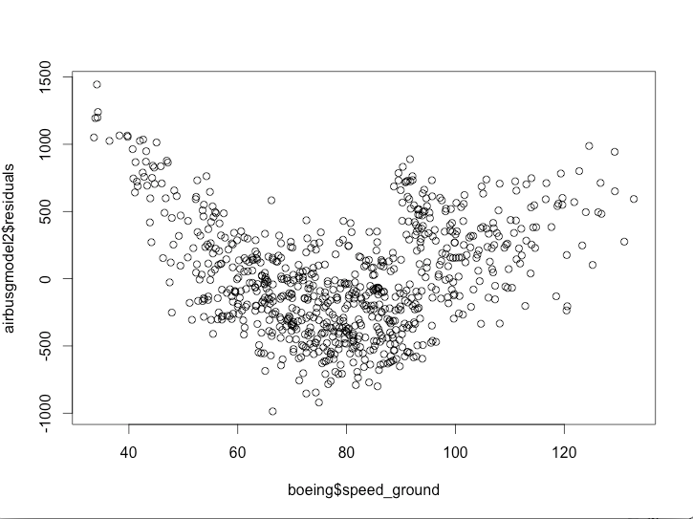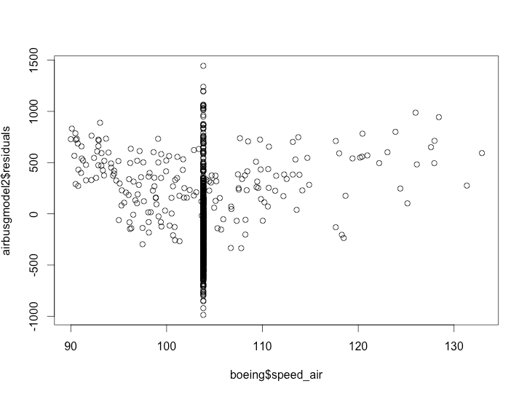

2.Normality

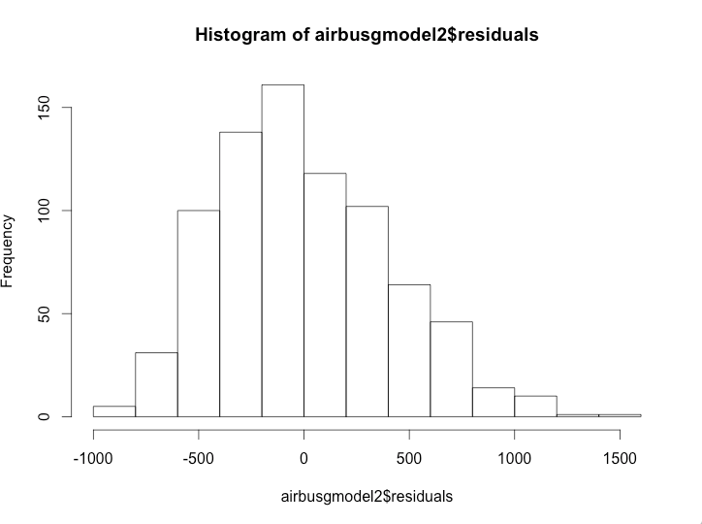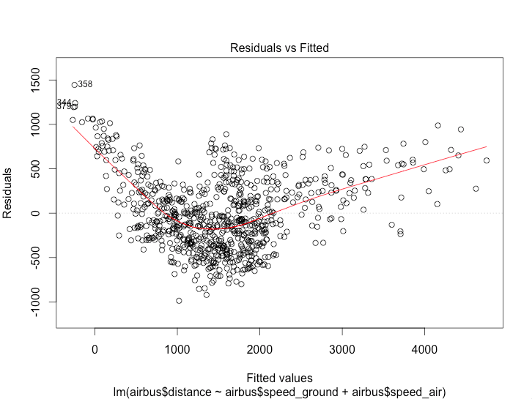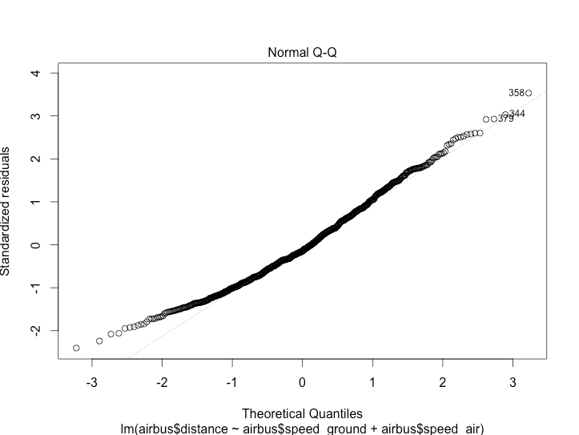

4. Constant variance

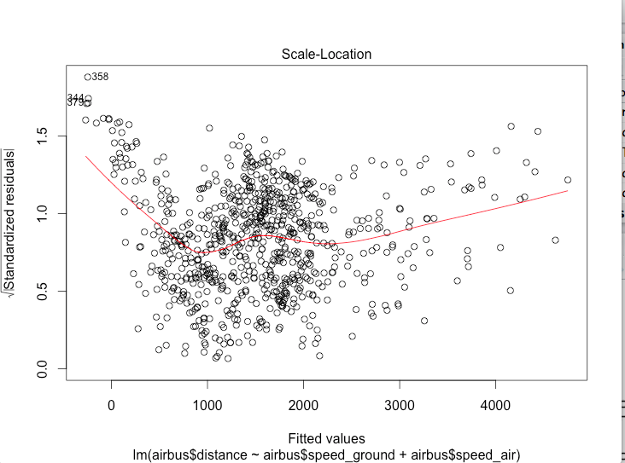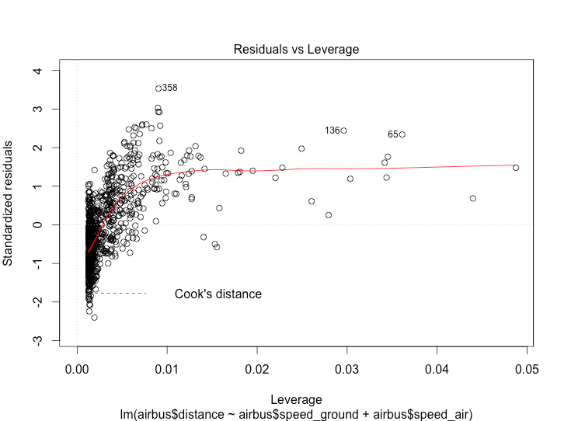

t.test(airbusgmodel2$residuals,finaldataset$speed_ground)

Welch Two Sample t-test

data: airbusgmodel2$residuals and finaldataset$speed_ground

t = -5.439, df = 793.34, p-value = 7.142e-08

alternative hypothesis: true difference in means is not equal to 0

95 percent confidence interval:

-108.14536 -50.78598

sample estimates:

mean of x mean of y

1.102370e-13 7.946567e+01

t.test(airbusgmodel2$residuals,finaldataset$speed_air)

Welch Two Sample t-test

data: airbusgmodel2$residuals and finaldataset$speed_air

t = -7.1081, df = 790.22, p-value = 2.634e-12

alternative hypothesis: true difference in means is not equal to 0

95 percent confidence interval:

-132.40103 -75.09782

sample estimates:

mean of x mean of y

1.102370e-13 1.037494e+02